PERFORMANCE BASED EVALUATION OF FACULTY BY STUDENTS

PART 1. BASIC INFORMATION
NAME OF THE TEACHER | COURSE | DEPARTMENT
EVALUATION PERIOD: FROM: TO:
PART 2. EVALUATION
2.1 Mark each item according to the following scale:
0= Poor, 1= Fair, 2= Good, 3= Excellent
TEACHING TECHNIQUES Poor Fair Good Excellent

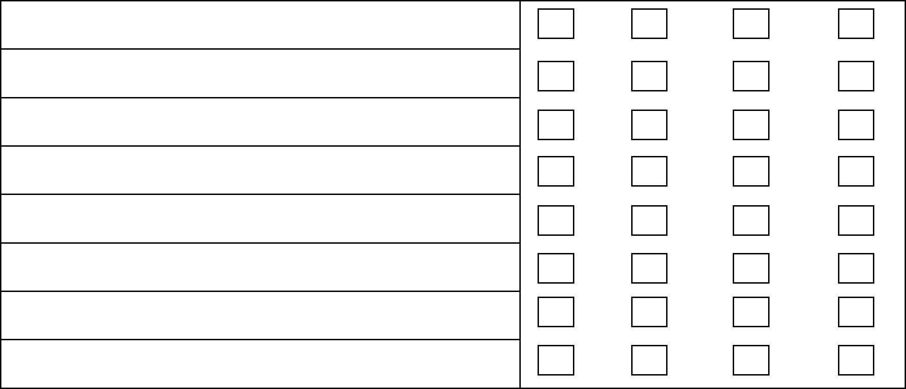
Stimulates student participation
Makes effective use of audio visuals resources
Makes clear and practical demonstrations
Makes use of logical and purposeful questions
Has a positive attitude
Demonstrates sufficient command of content
Provides interesting and adequate reinforcement
Provides motivation and leadership
Displays evidence of preparation
Directions to students are clearly thought out and well stated
Carefully plans student assignments / Quizzes for evaluation

STUDENT / TEACHER RELATIONSHIP | Poor | Fair | Good | Excellent
- Maintains student interest and attention
- Exhibits balance among voice control, and tact.
- Maintains a friendly and respectful teacher-student relationship

LECTURE ROOM ENVIRONMENT | Poor | Fair | Good | Excellent
- Environment is generally comfortable
- Arrives on time
- Leaves class on time
- Is fair in evaluation
- Presents reading, writing, speaking and listening strategies using concepts and language which students understand.

PROFESSIONALISM | Poor | Fair | Good | Excellent
- Has Professional behavior
- Maintains confidentiality
- Knowledge and skills of subjects area taught
- Provides information on recent and current
- developments in the subject

PART 3. COURSE

COURSE | Poor | Fair | Good | Excellent
The subject matter presented in the course has increased your knowledge of the subject
The course integrates theoretical concepts with real-world applications
The assignments and quizzes covered the materials presented in the course

RT 4. RESEARCH

RESEARCH | Poor | Fair | Good | Excellent
Helps in topic / research material search
Impact of teacher’s individual research / analytical skills on your project
Encourages and motivate in use of equipment in the laboratory
Motivates to publish your research findings in an appropriate scientific journal

PART 5. COMMENTS
Objective Comments, if any

Date

